SAFETY DATA SHEET
OSHA HCS (29 CFR 1910.1200)

SECTION 1: PRODUCT AND COMPANY IDENTIFICATION
Product identifier
 | Chemical Name | Mixture
 | CAS No. | Mixture
 | Trade Name | SPRAY PRODUCTS GLASS CLEANER
 | Product Code | 50-105843-1
Relevant identified uses of the substance or mixture and uses advised against
 | Identified Use(s) | Cleaning product
 | Uses Advised Against | None
 | Company Identification | Spray Products Corporation  P.O. Box 737  Norristown, PA 19404
 | Telephone | (610) 277-1010
 | Fax | (610) 277-4390
 | E-Mail (competent person) | SDS@SPRAYPRODUCTS.COM
Emergency telephone number
 | Emergency Phone No. | Transportation Emergency: CHEMTREC 24 hr. 1-800-424-9300 / 1 (703) 527-3887 (Collect calls accepted)

SECTION 2: HAZARDS IDENTIFICATION

Classification of the substance or mixture
 | OSHA HCS (29 CFR 1910.1200) | Liquefied gas
Label elements
 | Hazard Symbol | 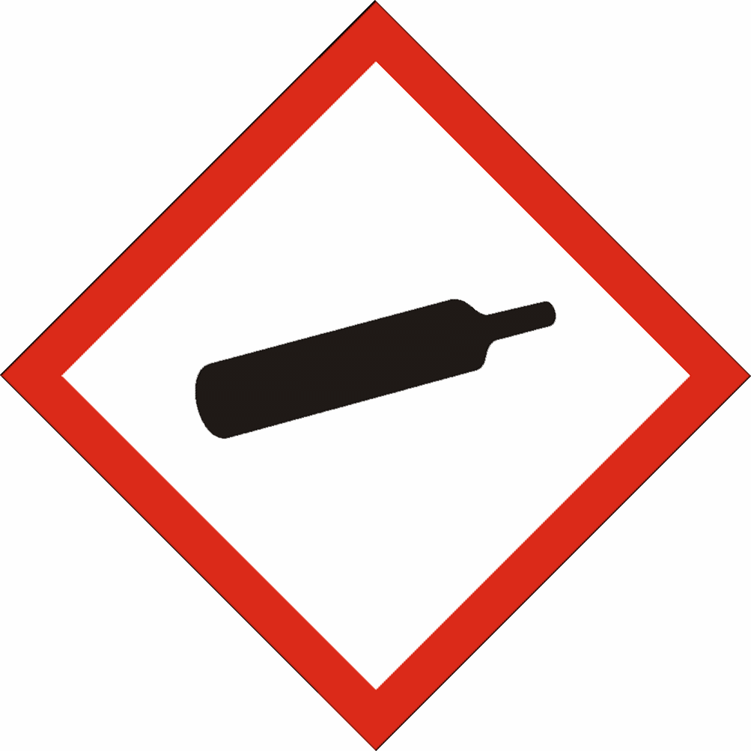
 | Signal word(s) | WARNING
 | Hazard Statement(s) | Contains gas under pressure; may explode if heated.
 | Precautionary Statement(s) | Protect from sunlight and store in well-ventilated place. Do not expose to temperatures exceeding 50°C/ 122°F.
Other hazards |  | None

SECTION 3: COMPOSITION/INFORMATION ON INGREDIENTS
Hazardous Ingredient(s) | % wt. * | CAS No. | Hazard classification
Propane | 1 - 5 | 74-98-6 | Flam. Gas 1, H220  Press. Gas (*)
Butane | 1 - 5 | 106-97-8 | Flam. Gas 1, H220  Press. Gas (*)
Diethylene glycol monobutyl ether | 2-5 | 112-34-5 | Eye Irrit. 2a; H319
Isopropanol | 2-5 | 67-63-0 | Flam. Liq. 2; H225  Eye Irrit. 2; H319  STOT SE 3; H336
2-Butoxyethanol | <1 | 111-76-2 | Acute. Tox. 4; H302, H312, H332  Skin Irrit. 2; H315  Eye Irrit. 2a; H319

Additional Information - None
* The exact percentage withheld as a trade secret in accordance with 29 CFR 1910.1200.

SECTION 4: FIRST AID MEASURES

Description of first aid measures
 | Inhalation |  | Move person to fresh air. If breathing is laboured, administer oxygen. If symptoms develop, obtain medical attention.
 | Skin Contact |  | Wash affected skin with soap and water. If symptoms develop, obtain medical attention.
 | Eye Contact |  | Rinse cautiously with water for several minutes. Remove contact lenses, if present and easy to do. Continue rinsing. If irritation develops and persists, get medical attention.
 | Ingestion |  | Immediately call a POISON CENTER or doctor/physician. Do not give anything by mouth to an unconscious person.
Most important symptoms and effects, both acute and delayed |  |  | None anticipated
Indication of any immediate medical attention and special treatment needed |  |  | None anticipated

SECTION 5: FIRE-FIGHTING MEASURES
Extinguishing Media
-Suitable Extinguishing Media |  | Extinguish with carbon dioxide, dry chemical, foam or waterspray.
-Unsuitable Extinguishing Media |  | Do not use water jet.
Special hazards arising from the substance or mixture |  | Pressurised container: May burst if heated
Advice for fire-fighters |  | A self contained breathing apparatus and suitable protective clothing should be worn in fire conditions. Keep containers cool by spraying with water if exposed to fire.

SECTION 6: ACCIDENTAL RELEASE MEASURES
Personal precautions, protective equipment and emergency procedures | Avoid contact with skin and eyes.
Environmental precautions | Prevent liquid entering sewers, basements and workpits.
Methods and material for containment and cleaning up | Cover spills with inert absorbent material.Transfer to a container for disposal or recovery.
Reference to other sections | None
Additional Information | None

SECTION 7: HANDLING AND STORAGE
Precautions for safe handling | Use product in a well-ventilated area only. Avoid contact with skin and eyes.
Conditions for safe storage, including any incompatibilities
-Storage temperature | Store in a well-ventilated place. Protect from sunlight. Do not expose to temperatures exceeding 50°C/ 122°F.
-Incompatible materials | This product should be stored away from sources of strong heat or oxidizing chemicals.
Specific end use(s) | Cleaning product

SECTION 8: EXPOSURE CONTROLS/PERSONAL PROTECTION
Occupational Exposure Limits
SUBSTANCE. | CAS No. | (8hr TWA) |  | (STEL) |  | Note:
SUBSTANCE. | CAS No. | PEL  (OSHA) | TLV (ACGIH) | PEL  (OSHA) | TLV (ACGIH) | Note:
n-Butane | 106-97-8 | ----- | 250 ppm | ----- | ----- | -----
Propane | 74-98-6 | 1000 ppm | Aspyx.# | ----- | ----- | #
Isopropanol | 67-63-0 | 400 ppm | 200 ppm | ----- | 400 ppm | -----
2-Butoxyethanol | 111-76-2 | 50 ppm | 20 ppm | ----- | ----- | -----
#Assure minimum oxygen content of work atmosphere.
Recommended monitoring method |  | NIOSH 1500 (hydrocarbons, B.P. 36 - 216 ºC); NIOSH 1400 (Alcohols I); NIOSH 1403 (Alcohols IV).
Exposure controls
Appropriate engineering controls |  |  |  | Use only with adequate ventilation to keep exposures (airborne levels of dust, fume, vapour etc) below recommended exposure limits.
Personal protection equipment
 | Eye/face protection   |  |  | Wear protective eyewear (goggles, face shield, or safety glasses).
 | Skin protection (Hand protection/ Other)   |  |  | Wear suitable gloves if prolonged skin contact is likely (Nitrile rubber).
 | Respiratory protection   |  |  | In case of insufficient ventilation, wear suitable respiratory equipment.
 | Thermal hazards |  |  | Not normally required.
Environmental Exposure Controls |  |  |  | None known

SECTION 9: PHYSICAL AND CHEMICAL PROPERTIES
Information on basic physical and chemical properties
Appearance | Liquid / Liquefied gas
Color. | Clear
Odor | Not available
Odor Threshold (ppm) | Not available
pH (Value) | Not available
Melting Point (°C) / Freezing Point (°C) | Not available
Boiling point/boiling range (°C): | Not available
Flash Point (°C) | Non-flammable
Evaporation Rate | Not available
Flammability (solid, gas) | Non-flammable
Explosive Limit Ranges | Not applicable
Vapor pressure (Pascal) | Not available
Vapor Density (Air=1) | Not available
Density (g/ml) | Not available
Solubility (Water) | Not available
Solubility (Other) | Not available
Partition Coefficient (n-Octanol/water) | Not available
Auto Ignition Point (°C) | Non-flammable
Decomposition Temperature (°C) | Not available
Kinematic Viscosity (cSt) | <20
Explosive properties | Not explosive.
Oxidizing properties | Not oxidizing.
Other information | Not available

SECTION 10: STABILITY AND REACTIVITY
Reactivity | Stable under normal conditions.
Chemical stability | Stable.
Possibility of hazardous reactions | None anticipated.
Conditions to avoid | Avoid contact with heat and ignition sources.
Incompatible materials | Strong oxidizing agents
Hazardous decomposition product(s)``` | None known

SECTION 11: TOXICOLOGICAL INFORMATION
Exposure routes: Inhalation, Skin Contact, Eye Contact

Mixtures
Acute toxicity |  | LD50 >5000 mg/kg-bw
Irritation / Corrosivity |  | Causes serious eye irritation.
Substances in preparations / mixtures
Propane (CAS# 74-98-6):
Acute toxicity |  | Inhalation: LC50 = 1237 mg/L (2-hr, mouse, gas)
Irritation/Corrosivity |  | No evidence of irritant effects from normal handling and use.
Sensitisation |  | It is not a skin sensitiser.
Repeated dose toxicity |  | NOAEC: >19678 mg/m3 (28-day, rat, Systemic effects)  LOAEC: 21641 mg/m3 (28-day, rat, effects: Body weight)
Carcinogenicity |  | No data. It is unlikely to present a carcinogenic hazard to man.
Mutagenicity |  | There is no evidence of mutagenic potential.
Reproductive toxicity |  | None anticipated
Isopropanol (CAS# 67-63-0):
Acute toxicity | Oral: LD50 = 5.84 g/kg (rat)  Inhalation: LC50 > 1000 ppm (rat) 6 hour(s)  Dermal: LD50 = 16.4 ml/kg (rabbit) 24 hour(s)  May cause drowsiness or dizziness.
Irritation/Corrosivity | Irritating to eyes.
Sensitization | It is not a skin sensitizer.
Repeated dose toxicity | NOAEL = 5,000 ppm (Inhalation)  May cause drowsiness or dizziness.
Carcinogenicity | It is unlikely to present a carcinogenic hazard to man.
Mutagenicity | There is no evidence of mutagenic potential.
Reproductive toxicity | Not available

SECTION 12: ECOLOGICAL INFORMATION
Isopropanol (CAS# 67-63-0):
Short term | LC50 (96 hour): 10,000 mg/l (Fathead minnow (Pimephales promelas))  LC50 24hour(s): >10,000 mg/l (Daphnia magna)
Long Term | NOEC: 3.37 µmol/l (Daphnia magna) (Growth rate)
Persistence and degradability | Not available.
Bioaccumulative potential | Not available.
Mobility in soil | Not available.
Results of PBT and vPvB assessment | Not classified as PBT or vPvB.
Other adverse effects | None known.

SECTION 13: DISPOSAL CONSIDERATIONS
Waste treatment methods | Disposal should be in accordance with local, state or national legislation. Consult an accredited waste disposal contractor or the local authority for advice.

SECTION 14: TRANSPORT INFORMATION
 | U.S. DOT | Sea transport  (IMDG) | Air transport (ICAO/IATA)
UN number | 1950 | 1950 | 1950
Proper Shipping Name | Aerosols, non-flammable | Aerosols, non-flammable | Aerosols, non-flammable
Transport hazard class(es) | 2.2 | 2.2 | 2.2
Packing group | Not applicable | Not applicable | Not applicable
Environmental hazards | None assigned | None assigned | None assigned
Special precautions for user | None assigned | None assigned | None assigned
Transport in bulk according to Annex II of MARPOL73/78 and the IBC Code: Not applicable

SECTION 15: REGULATORY INFORMATION
Safety, health and environmental regulations/legislation specific for the substance or mixture:
TSCA (Toxic Substance Control Act) - Inventory Status: All components listed or polymer exempt.
Designated Hazardous Substances and Reportable Quantities (40 CFR 302.4):
 |  |  | Chemical Name | CAS No. |  |  | Typical %wt. |  |  |  | RQ (Pounds)
 |  |  | NONE | ------ |  |  | ---- |  |  |  | -----
SARA 311/312 - Hazard Categories: See SECTION 2: HAZARDS IDENTIFICATION
SARA 313 - Toxic Chemicals (40 CFR 372):
 |  |  | Chemical Name |  |  |  |  | CAS No. |  |  |  |  | Typical %wt.
 |  |  | NONE |  |  |  |  | ------- |  |  |  |  | -----
SARA 302 - Extremely Hazardous Substances(40 CFR 355):
 |  |  | Chemical Name |  |  | CAS No. |  |  |  | Typical %wt. |  | TPQ (pounds)
 |  |  | None |  |  | ---- |  |  |  | ---- |  | ----
California Proposition 65 List:
 |  | Chemical Name |  |  | CAS No. |  |  |  | Type of Toxicity
 |  | NONE |  |  | ----- |  |  |  | -----

SECTION 16: OTHER INFORMATION
The following sections contain revisions or new statements: 1-16.
Date of preparation: APRIL 5,2016
Hazard Statement(s) and Risk Phrases Listed in: SECTION 2:/ SECTION 3:
Hazard Statement(s)
- H220: Extremely flammable gas.
- H225: Highly flammable liquid and vapour.
- H301: Toxic if swallowed.
- H302: Harmful if swallowed.
- H311: Toxic in contact with skin.
- H312: Harmful in contact with skin.
- H315: Causes skin irritation.
- H318: Causes serious eye damage.
- H319: Causes serious eye irritation.
- H330: Fatal if inhaled.
- H332: Harmful if inhaled.
- H335: May cause respiratory irritation.

Training advice: None.
Disclaimer: We believe the statements, technical information and recommendations contained herein are reliable, but they are given without warranty or guarantee of any kind. The information contained in this document applies to this specific material as supplied. It may not be valid for this material if it is used in combination with any other materials. It is the user’s responsibility to satisfy oneself as to the suitability and completeness of this information for the user’s own particular use.

